**الأسم: ------------------------- التاريخ: ----------------**

**الفصل: -----------------**

**مراجعة** 3

1. **أكتبي الكلمه تحت الصورة :**

[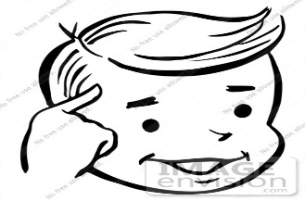](https://www.google.com.eg/url?sa=i&rct=j&q=&esrc=s&source=images&cd=&cad=rja&uact=8&ved=0ahUKEwiKx87T5tTQAhXBVRoKHWrvDvkQjRwIBw&url=https://www.clipartsgram.com/thinking-smiley-clipart-black-and-white-376&psig=AFQjCNGlPKUP5zE9afTKmmcmm-IhaPvpwA&ust=1480743789527136)[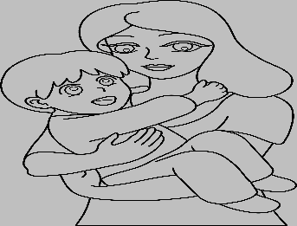](https://www.google.com.eg/url?sa=i&rct=j&q=&esrc=s&source=images&cd=&cad=rja&uact=8&ved=0ahUKEwje9_q25dTQAhXDVhoKHfg1Cf8QjRwIBw&url=http://worldartsme.com/mother-black-and-white-clipart.html&bvm=bv.139782543,d.d2s&psig=AFQjCNHtJDOWwFVVHv4pDibFRAgORrR3rg&ust=1480743402875405)[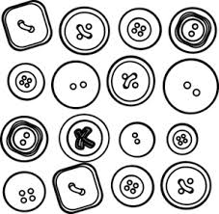](http://www.google.com.eg/url?sa=i&rct=j&q=&esrc=s&source=images&cd=&cad=rja&uact=8&ved=0CAcQjRw&url=http://pixgood.com/sewing-buttons-clip-art.html&ei=xNygVMWZK5Pvaor5gpgK&bvm=bv.82001339,d.d2s&psig=AFQjCNFQ1aJPPB2mQYZiPOAqkvSh6gB1Ag&ust=1419914790488729)

**[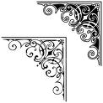](http://images.google.com/imgres?imgurl=http://www.istockphoto.com/file_thumbview_approve/2906384/2/istockphoto_2906384-corner-art-design.jpg&imgrefurl=http://www.istockphoto.com/file_closeup.php?id=2906384&refnum=little_bobek&usg=__4_w8q4gG1EjHn8XcWT7SpwAj-o0=&h=380&w=378&sz=41&hl=en&start=34&itbs=1&tbnid=7UAbzWUdNu6kfM:&tbnh=123&tbnw=122&prev=/images?q=corner&start=21&hl=en&sa=N&imgtype=lineart&imgc=gray&as_st=y&ndsp=21&tbs=isch:1)**

**2- أكتبي الحرف الناقص :**

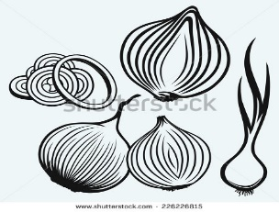[](https://www.google.com.eg/url?sa=i&rct=j&q=&esrc=s&source=images&cd=&cad=rja&uact=8&ved=0ahUKEwj76YKs9NTQAhXEPxoKHVwHDN4QjRwIBw&url=http://www.shutterstock.com/s/rain%2Bboots/search-vectors.html&bvm=bv.139782543,d.d2s&psig=AFQjCNFkYackOQWEbqrk1nE3OmQi3clVFA&ust=1480747426727760)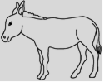[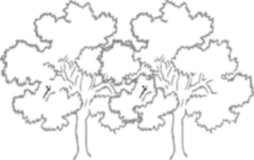](https://www.google.com.eg/url?sa=i&rct=j&q=&esrc=s&source=images&cd=&cad=rja&uact=8&ved=0ahUKEwiNi4qr99TQAhWIExoKHX0KAuwQjRwIBw&url=https://www.clipartsgram.com/two-trees-clipart-black-and-white-1914&bvm=bv.139782543,d.d2s&psig=AFQjCNG7oDsKwSUy0gb4KHj0uBolAzREog&ust=1480748241171201)

**.....ــصل شـ.....ــاء .....ــجر حما.....**

**3– إختارى الكلمة المناسبة الداله على الصورة:**

[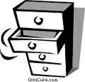](http://www.google.com.eg/url?sa=i&rct=j&q=&esrc=s&source=images&cd=&cad=rja&uact=8&ved=0CAcQjRw&url=http://dir.coolclips.com/Household/Bedroom/Drawers_and_Cabinets/Chest_of_drawers_hous0447.html&ei=FN-gVI3ICI3vaLSugOAH&bvm=bv.82001339,d.d2s&psig=AFQjCNFeZurMqvr5dgRGEdojRwG5icBQyA&ust=1419915333427663)

**( درج - برج )**

C:\Users\A1\Pictures\Microsoft Clip Organizer\j0426054.wmf

**( كنب – كتب )**

[](http://www.google.com.eg/url?sa=i&rct=j&q=&esrc=s&source=images&cd=&cad=rja&uact=8&ved=0CAcQjRw&url=http://www.graphicsfactory.com/Clip-Art/Business/index.html&ei=TTqoVMLYJ4rkaPOigpgB&bvm=bv.82001339,d.d2s&psig=AFQjCNHkGtAeP46XSnwFngpPFojXw001Ww&ust=1420397499508863)

**( رَجل – رِجل )**

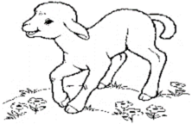

**( حمل – جمل )**